FOC C PROGRAM PRACTICAL SESSION

S.JYOTHI KOUSHIK

192211914

1.GENERATION OF NUMBERS IN SERIES 1,2,3,4,……N

3.GENERATION OF ODD NUMBER OF SERIES;

4. Generation of Fibonacci series 0, 1, 1, 2, 3, 5, 8, …..n

5. Summing up series 1 + 2 + 3 + 4….. +n

6. Summing up Even Number series

7. Summing up Odd Number series

8. Summing up 1 – 2 + 3 – 4 + 5…. N

9. Summing up squares of natural numbers 1 + 2 + 3 + 4….. +n

10. Summing up squares of natural even numbers 2 + 4+ 6+ 8 + ….. n

11.simple interest

12.negative number

13.calculator

14.conversion of binary to decimal

15.conversion of decimal to binary

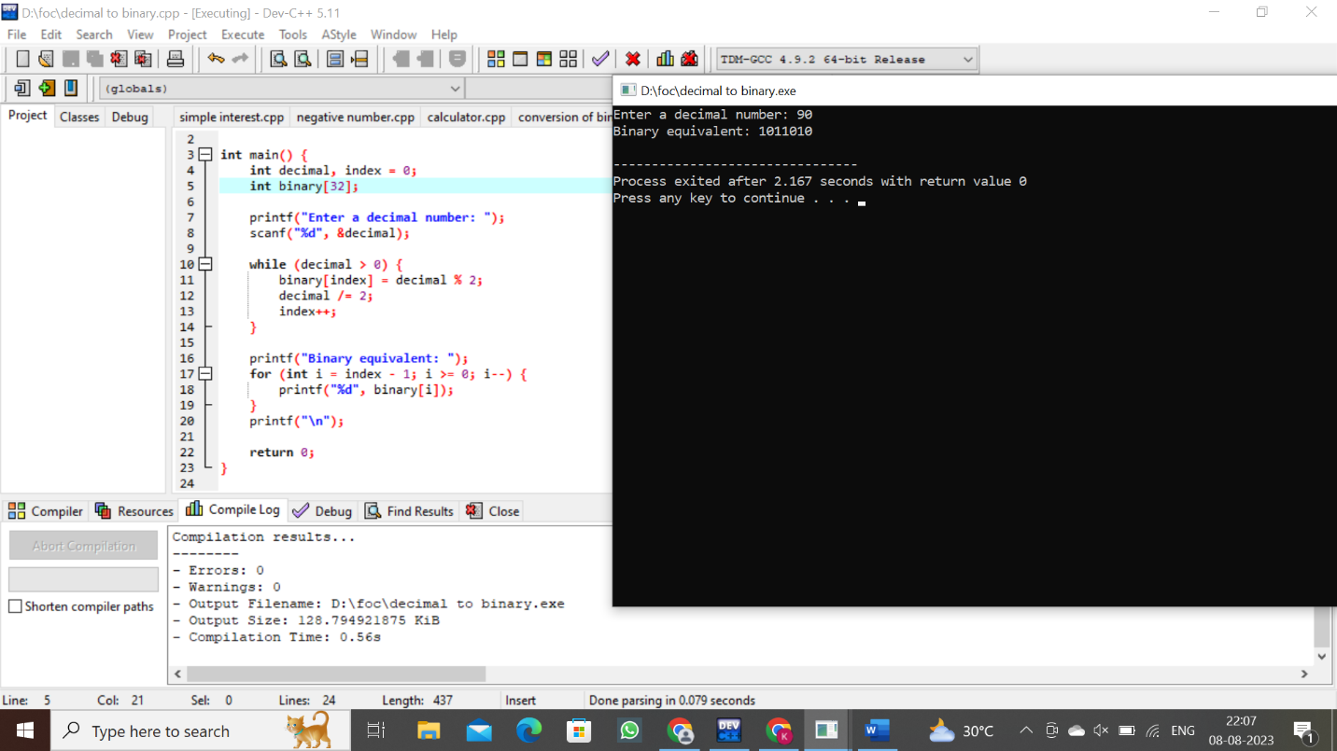

16.elements from array and its display position

17.length of a string

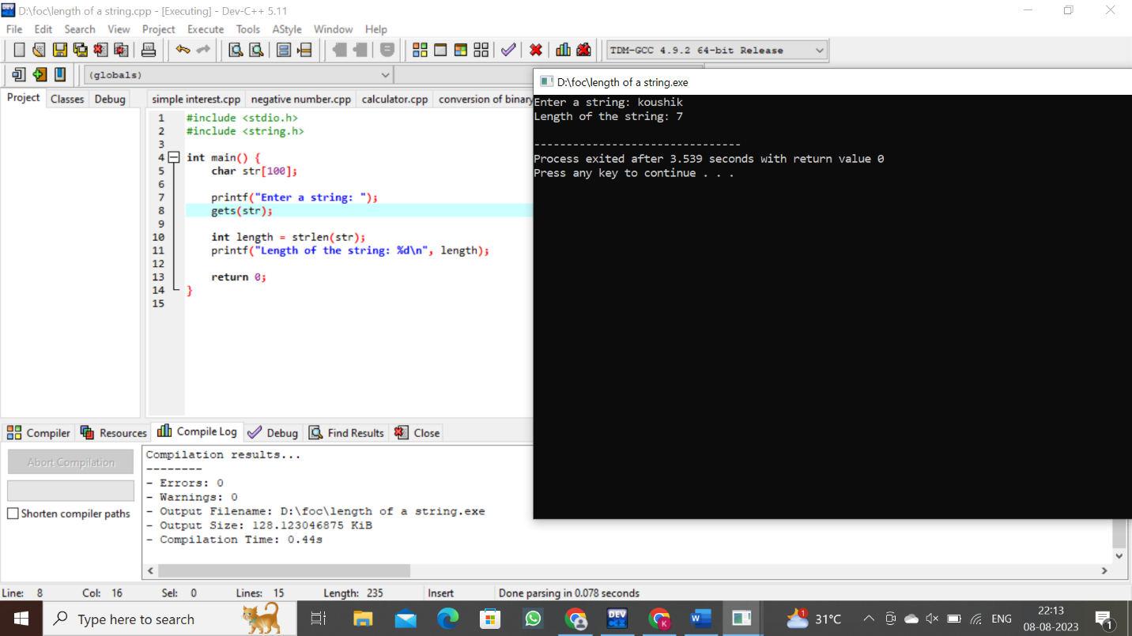

18.pattern

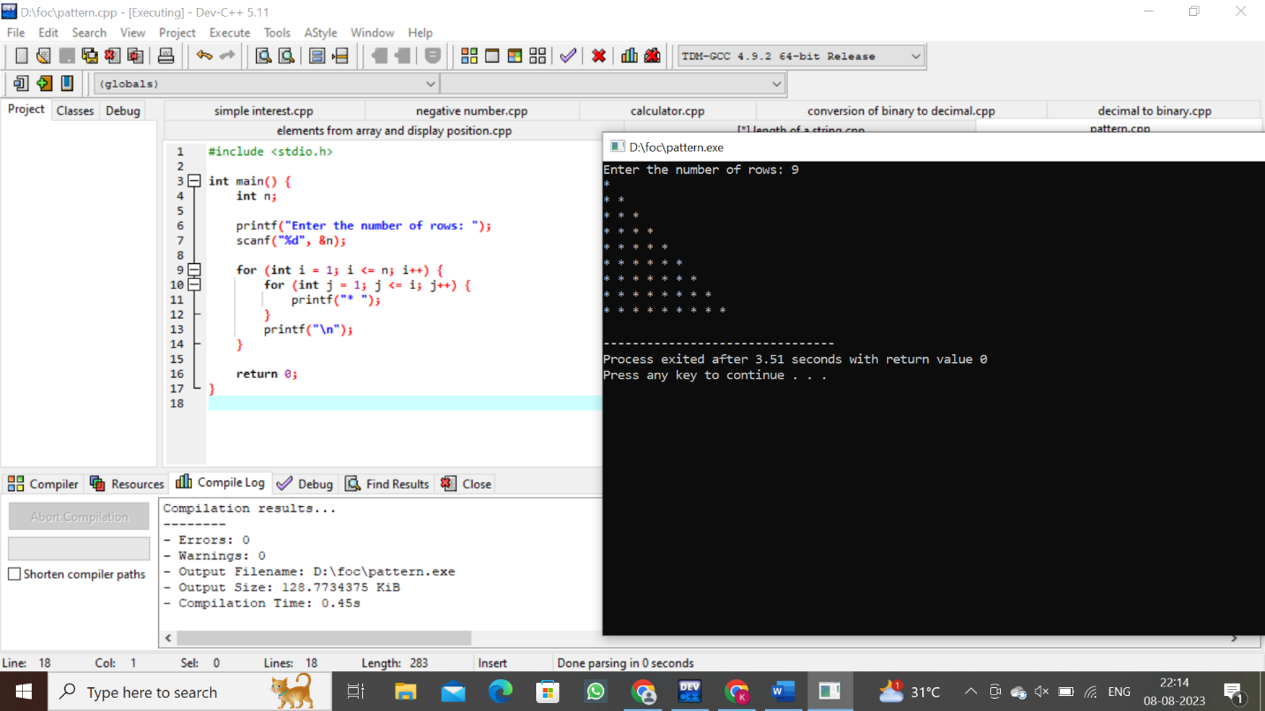

19.sum of elements in an array

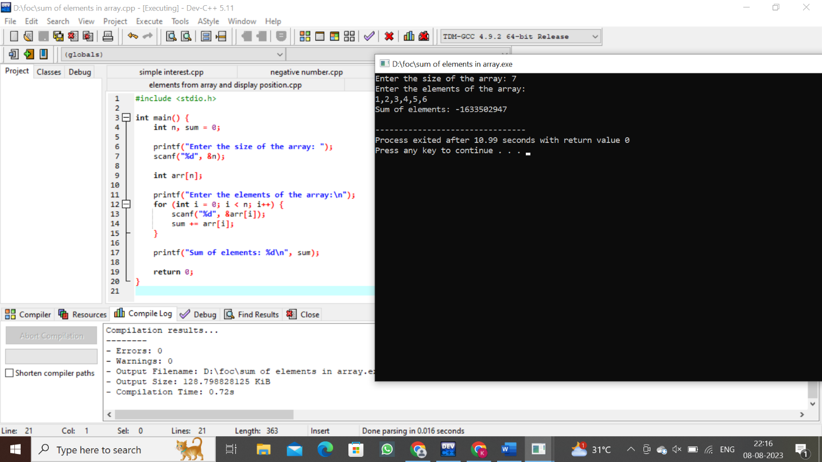

20.merge elements in array

